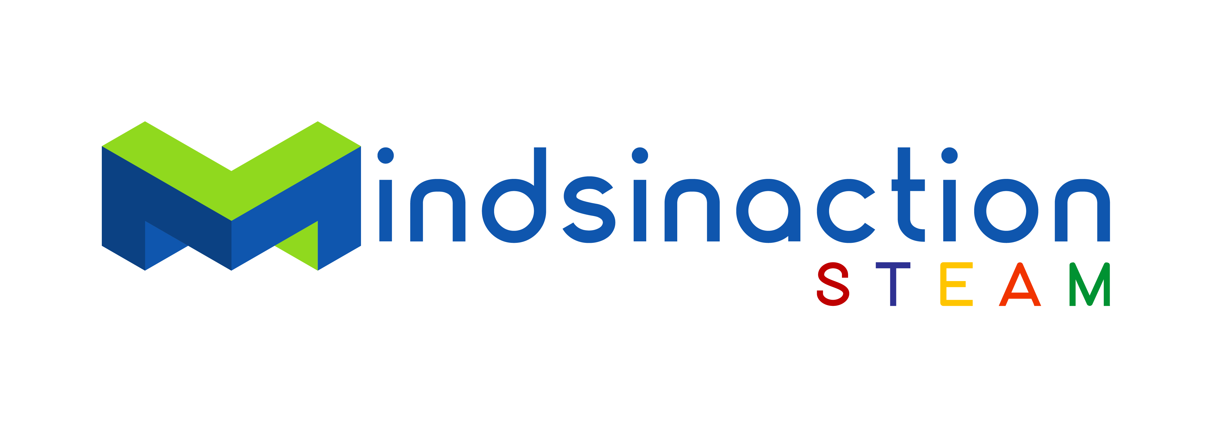
Registration Form
ROBOTIC COURSE 2nd Term 2024

Hereby I register my child for the Mindsinaction STEAM Programme at the Goethe-Institut Namibia.

Level 0 Dash Robot & Programming (6 to 8 years)

Level 1 Lego Robotics & Programming (8 to 16 years)

Level 2 Coding with Kitten, Gaming and Animation (8 to 16 ys.)

Level 3 Electronics and Coding with Arduino (8 to 16 years)

Details parents:

Name of Parent

Cell Nr 1: Cell Nr 2:

E-Mail Address:

Details Child:

Name:

Surname:

Age: Cell Phone:

Windhoek, Date Signature:

Terms and conditions:
Course starts 20.06.2024 at 10h00,
All Levels Saturdays. (Dates and time are subject to change).
If enrolment in a particular group is insufficient on the starting date, we reserve the right to adjust the course format. Should we not have enough course participants, we reserve the right to cancel a course.

Full payment of 1 800 NAD per learner required prior to their participation.
Please attach proof of payment.

No refunds will be paid once the course has started. A cancellation fee of 20% is payable before course commencement. Cancellations must be done in writing.
The Goethe-Institut cannot be held liable and accepts no responsibility for any injury, damage and/or loss to course participants and their belongings.
By signing above, you agree to have read and understood the terms and conditions.

