**Professional Programme for Publishers**

**EU4Dialogue/ Goethe-Institute Georgien / Frankfurter Buchmesse**

Programme duration: 16-20.10.2023 – Frankfurt, Germany

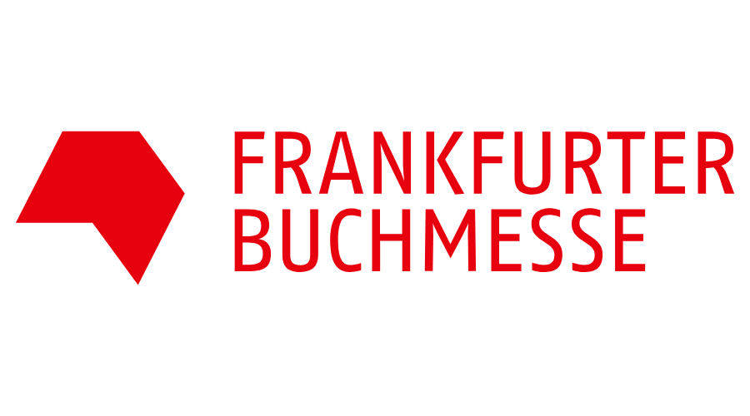Application deadline: June 23, 2023

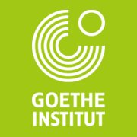

|  |  |
| --- | --- |
| APPLICATION FORM | |
| Last name: |  |
| First name: |  |
| City of Residence, Street, postal code: |  |
| Phone: |  |
| E-Mail: |  |
| City of Origin: |  |
| Citizenship (passport): |  |
| Language skills |  |
| Professional publishing experience |  |
| Name of publishing House: |  |
| Position: |  |
| Introduce yourself - who you are, what do you do and for what are you responsible in the publishing house/literature agency? |  |
| Short Description of the publishing house (Year of foundation, how many titles are published annually, approx. how many employees work at the publishing house?)  Please, indicate the link of the publishing house |  |
| What is the profile of your publishing house |  |
| Have you been to the Frankfurt Book Fair? If yes, when? |  |
| Please indicate which topic(s) would you like to discuss during the professional program. |  |
| What are your expectations? |  |
| Please confirm your full-time availability between 16-20 October, 2023. Yes/No |  |
| Special needs (optional) |  |